2019

Radiology Information System User Manual

ADVANCED SOFTWARE ENGINEERING

EVAN MYERS, MATT WILLIAMS, IAN NEER, BRISAAC JOHNSON, DAKOTA NATION, KEVIN MITCHELL, DARIUS FIALLO, ALEC CROMER

Table of Contents

1. Introduction: 1

2. Referring Physician: 3

2.1 Refer Patient: 3

2.2 Check Patient Information/Status: 3

3. Administrative assistant: 4

3.1 Create Patient 4

3.2 Edit and Delete Patient 4

3.3 Create Appointment 4

3.4 Edit Appointment 4

3.5 View Patient Procedures to export for Billing 5

3.6 Create Billing Form 5

3.7 Send Billing Form 5

3.8 View Previous Reports 5

4. Technician: 6

4.1 Access Patient Appointments 6

4.2 Access Patient Conditions 6

4.3 View all Procedures 6

4.4 View Resources 6

5. Patient: 7

6. Radiologist: 8

6.1 View Incomplete Procedures 8

6.2 Write Procedure Results 8

6.3 Access Completed Reports 8

6.4 Access Patient Information 8

6.5 Update or Delete Patient Information 8

6.6 View Procedure Status 9

Radiology Information System (RIS) User Manual

# 1. Introduction:

The purpose of the Radiology Information System (RIS) is to facilitate the procedure required for a patient to go through the imaging process. In this system, there are many people with access to different steps throughout the system. This manual is divided into categories based on the role of the user, then subdivided by task for efficient use by the user.

The workflow of the system is displayed in the picture below along with a brief summary:

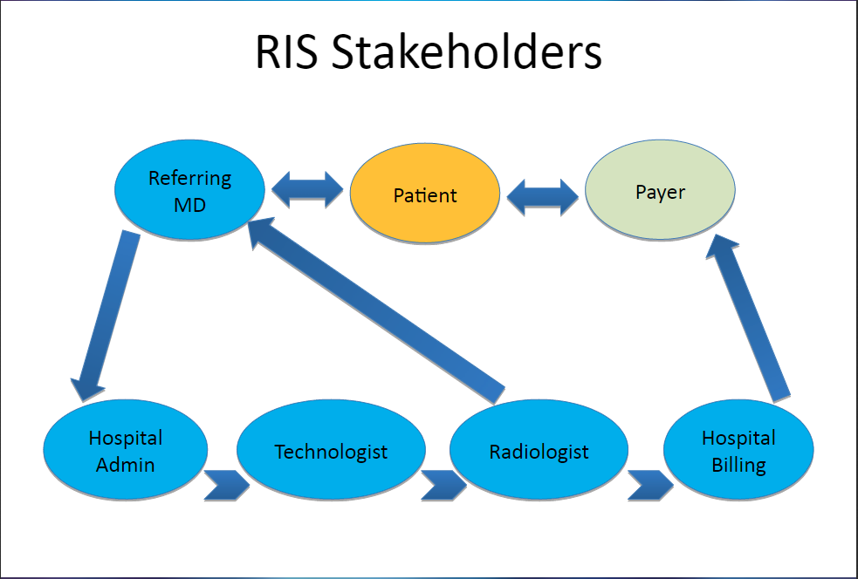

The Referring Physician will contact the Hospital Admin to input new patient information and schedule appointments. Once the appointment is made, the technician will perform the imaging process and submit a tech report that will be sent to the radiologist. Once the radiologist reviews the imaging information, he will write a final review that will be accessible by the referring physician who will review the findings with the patient. After the review is complete, the billing will be reviewed and finalized by the administrative assistant and the final bill will be sent to the payer for processing.

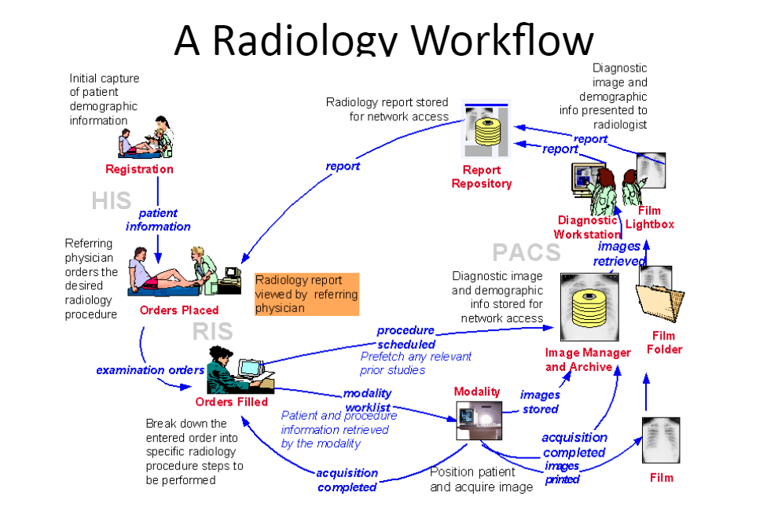

Pictured above is an in-depth analysis of the flow of processes in the Radiology Information System. Covered is the process from the patient being registered through the Hospital Information System and ends when the patient receives the final report from the physician. This is a more technical diagram that explores how PACS is accessed and how the picturing processes are completed and does not discuss the billing process.

It can be seen that once the patient is registered and the orders are placed, the administrative assistant must break the orders into a certain technician and modality for the schedule. The technician will then work with the modality to acquire a useable image to upload to PACS. The radiologist is then able to retrieve the image from PACS to review and use to reach an indication. Once the radiologist completes his report, it is sent to the report repository and made accessible to the referring physician.

## 2. Referring Physician:

The referring physician is responsible for inputting patient information and requesting a procedure. The referring physician can also look a patient up during the process to check status and radiologist report associated with procedures they requested.

### 2.1 Refer Patient:

From the main menu screen after login, click on the referrals tab. Once the referrals tab is open, click “add new referral” button and fill in the appropriate boxes. Once the boxes are filled, click the “submit” button and this will input the patient into the system. If there is a problem with one of the fields, it will be outlined in red and the form will only be submitted once this problem is fixed.

### 2.2 Check Patient Information/Status:

A referring physician can only access the information and status of a patient that they referred to the clinic. To check the patient information, click on the “patient list” tab on the left side of the screen. This will open a list of all the patients associated with the physician that is currently logged in. You can double click the patient in the table to access a more detailed review of the information pertaining to the patient including results from previous appointments.

To check the status of a patient currently in the clinic, click the “worklist” tab. This will display the worklist with a status for each patient that has been referred by the physician.

## 3. Administrative assistant:

The administrative assistant is responsible for many administrative tasks that the clinic provides. They will be able to create or edit patient data, schedule an appointment for a patient, and look at the already scheduled appointments for patients. The administrative assistant can also view procedure data, create and send billing documents, and view files (all archived procedures stored in the system).

### 3.1 Create Patient

Log-in to the system using your credentials. Upon logging in, on the left hand side of the screen, in the side menu, you will see a tab called Patient List. Click this option to view a list of all the patients in the system. In the upper right hand corner of the screen, click on create new patient. In the dialog box that appears, fill in the desired patient information. Once complete, click submit to add the patient into the system. If any errors exist in the entry, the boxes will be outlined in red. Fix the errors and click submit again.

### 3.2 Edit and Delete Patient

Log-in to the system using your credentials. Upon logging in, on the left hand side of the screen, in the side menu, you will see a tab called Patient List. Click this option to view all the patients in the system. Search or filter for the patient’s whom you are wishing to access. Once the desired patient is found, double click on the patient’s name. Click on the edit patient information option in the center of the screen. Edit the information. Once complete, click on the submit option to the right of the form.

### 3.3 Create Appointment

Log-in to the system using your credentials. Upon logging in, on the left hand side of the screen, in the side menu, you will see a tab called Appointment List. Click this option to view all the appointments in the system. The screen that appears will allow you to create a new appointment. Click on the create new appointment option in the upper right of the screen. Enter the Patient ID, select the desired date for the appointment, and the select the procedure type. Finally, click submit at the bottom right of the dialog box. This creates a new appointment.

### 3.4 Edit Appointment

Log-in to the system using your credentials. Upon logging in, on the left hand side of the screen, in the side menu, you will see a tab called Appointment List. Click this option to view all the appointments in the system. Search for the appointment you are wishing to access. Once the desired appointment is found, double click on the appointment. Click on the edit appointment information option in the center of the screen. Edit the information. Once complete, click on the submit option to the right of the form.

### 3.5 View Patient Procedures to export for Billing

Log-in to the system using your credentials. Upon logging in, on the left hand side of the screen, in the side menu, you will see a tab called Billing. Click this option to view all the procedures that are available to export for billing.

### 3.6 Create Billing Form

The RIS will automatically create the billing form from the information inserted in the tech entry. To finish the process, you must click the billing tab on the left menu part of the screen. Once the billing section is opened, click on a patient to review the billing information. You can then send the invoice.

### 3.7 Send Billing Form

Log-in to the system using your credentials. Upon logging in, on the left hand side of the screen, in the side menu, you will see a tab called Billing. Click this option to view all the bills in the system. Find the bill you are wishing to access. Once the desired bill is found, double click on it. Click send invoice.

### 3.8 View Previous Reports

Log-in to the system using your credentials. Upon logging in, on the left hand side of the screen, in the side menu, you will see a tab called Files. Click this option to view all the previous reports in the system. Find the report you are wishing to access by searching using the search bar in the upper left or filter the columns by clicking on the column title. Once the desired report is found, double click on it to view.

## 4. Technician:

The technician is the person responsible for performing the imaging process. They can view patient appointments, the worklist, and patient data of patients that are assigned to them. The technician can also submit an image and write a tech entry that will be sent to the radiologist to aid him in the reviewing process.

### 4.1 Access Patient Appointments

Log-in to the system using your credentials. Upon logging in, on the left hand side of the screen, in the side menu, you will see a tab called Appointments List. Click this option to view all the appointments in the system. Find the appointment you are wishing to access. Once the desired appointment is found, double click on it to access it.

### 4.2 Access Patient Conditions

Log-in to the system using your credentials. Upon logging in, on the left hand side of the screen, in the side menu, you will see a tab called Patient List. Click this option to view all the patients in the system. Search or filter for the patient’s whom conditions you are wishing to access. Once the desired patient is found, double click on it.

### 4.3 View all Procedures

Log-in to the system using your credentials. Upon logging in, on the left hand side of the screen, in the side menu, you will see a tab called Report List. Click this option to view all the procedures in the system. Filtering for incomplete procedures can be done by clicking the incomplete button in the upper right hand corner of the screen.

### 4.4 View Resources

Log-in to the system using your credentials. Upon logging in, on the left hand side of the screen, in the side menu, you will see a tab called Procedure List. Click this option to view all the available resources.

## 5. Patient:

The patient does not have access to the RIS; however, it is important that they know who they can talk to throughout the process to edit their information, check them in, and provide billing information. The patient will interact the most with the administrative assistant.

## 6. Radiologist:

The Radiologist is responsible for viewing the images that were acquired by the technician. After viewing the images, the Radiologist will write a report containing the results from his study. The Radiologist will send the completed report back to the clinic for distribution to the patient and insurance company.

### 6.1 View Incomplete Procedures

Log-in to the system using your credentials. Upon logging in, on the left hand side of the screen, in the side menu, you will see a tab called Report List. Click this option to view all the procedures in the system. Filtering for incomplete procedures can be done by clicking the incomplete button in the upper right hand corner of the screen.

### 6.2 Write Procedure Results

Log-in to the system using your credentials. Upon logging in, on the left hand side of the screen, in the side menu, you will see a tab called Report List. Click this option to view all the procedures in the system. Next, you can filter for incomplete procedures using the process above to make finding the desired procedure easier. Once locating the procedure that needs results, double click. A dialog box will open that allows you to input the reason for the exam, clinical history, and findings. Once the input is complete, click submit report at the bottom of the dialog box.

### 6.3 Access Completed Reports

Log-in to the system using your credentials. Upon logging in, on the left hand side of the screen, in the side menu, you will see a tab called Report List. Click this option to view all the procedures in the system. Filtering for complete procedures can be done by clicking the complete button in the upper right hand corner of the screen.

### 6.4 Access Patient Information

To access patient information, first, log in to the system. Then click on the Patient List option in the left menu bar. This will populate the screen with a list of all patients in the system. To better filter the results, click on the column you would like to search by and the type your desired search into the search bar. Double click on the patient information you would like to access.

### 6.5 Update or Delete Patient Information

To update or delete patient information, first, log in to the system. Then click on the Patient List option in the left menu bar. This will populate the screen with a list of all patients in the system. To better filter the results, click on the column you would like to search by and the type your desired search into the search bar. Double click on the patient information you would like to update or delete. Next, click on the edit patient information option at the top of the screen. Edit the patient information, and then click the submit button to the right.

### 6.6 View Procedure Status

Log-in to the system using your credentials. Upon logging in, on the left hand side of the screen, in the side menu, you will see a tab called Appointment List. Click this option to view all the appointments in the system and their procedure status.